**Spacetime Diagrams and Einstein’s Theory**

**For**

**Dummies**

A Set of Five Lesson Plans for School Teachers

Dr. Muhammad Ali Yousuf

Assistant Program Manager

CTY Summer Programs

And

Physics and Mathematics Instructor

CTY Online Programs

Johns Hopkins Center for Talented Youth

[mali@jhu.edu](mailto:mali@jhu.edu)

Dr. Igor Woiciechowski

Associate Professor of Mathematics

Alderson-Broaddus University

[woiciechowskiia@ab.edu](mailto:woiciechowskiia@ab.edu)

Version 1.0, 11/4/2016



Contact Dr. M. Ali Yousuf at [mali@jhu.edu](mailto:mali@jhu.edu) for electronic copies of this document

Contents

**Lesson 1: Description of Motion, Galilean Relativity Principle** 3

Teacher’s Guide 3

Student’s Worksheet 5

**Lesson 2: Introduction to Spacetime Diagrams and the Light Cone** 7

Teacher’s Guide 7

Student’s Worksheet 9

**Lesson 3: Regions on Spacetime Diagram** 11

Teacher’s Guide 11

Student’s Worksheet 14

**Lesson 4: Relativity of Simultaneity** 17

Teacher’s Guide 17

Student’s Worksheet 19

**Lesson 5: Resolving the Twin Paradox** 22

Teacher’s Guide 22

Student’s Worksheet 23

# **Lesson 1: Description of Motion, Galilean Relativity Principle**

## Teacher’s Guide

**Connections:**

|  |  |  |
| --- | --- | --- |
| Previous Lesson | Current Lesson | Next Lesson |
| Basic Mechanics | Description of Motion, Galilean Relativity Principle | Introduction to spacetime diagrams |

|  |  |
| --- | --- |
| Objectives: | * To formulate and discuss the Galilean Relativity Principal * To understand which physical quantities do not change (are invariants) and which are not invariant |
| Review: | **A Frames of Reference** is a system of geometric axes in relation to which measurements can be made. For example, in two dimensions:  Slide1  **Inertial frames** are systems moving at constant speed. Which means if you measure acceleration ‘inside’ that system, it will be zero. A car moving with constant speed on a straight road is a good approximation.  **Galilean relativity** states that the laws of motion are the same in all inertial frames. |
| Video(s): | Watch the interesting video before starting: Galilean Relativity, <https://www.youtube.com/watch?v=uJ8l4kh_jto> |
| Mathematics Review: | Student should know basic algebra.  Basic concepts of Cartesian geometry are part of the lesson plan. |
| Questions to start the discussion: | Start lesson from the question “How do you know you are moving or are at rest?” You can give several examples:  You are in a car moving at **constant** speed,  you are in a car **stopped** at the traffic signal,  you are sitting in the cabin of an airplane which is cruising, etc.  Convince students that there is no way to tell without looking out of the window or identifying a frame of reference. This is what the Principle of Relativity says. |
| Main Activity | How to measure the distance between two places in some coordinate system?  If we take another coordinate system that is translated (moved) relative to the first one what will be the distance?  The conclusion: The distance between two points does not depend on the coordinate system chosen!  How to measure relative speeds. |
| Discussion Questions - Closure | A number of follow up questions can now be asked to prepare for the next class   1. What does the Galilean Relativity Principle state? 2. How can you formulate the Rule of Addition of Velocities? 3. What physical quantities are invariant at transitions between inertial frames of reference? |
| Fun fact | The passage available at <https://en.wikipedia.org/wiki/Galileo%27s_ship>  Has been taken from Galilei’s book shows how he had used a ship to describe inertial motion. Later books used trains and recent textbook would probably also use train or car experience as there is a higher probability that a modern reader has experienced them, rather than ships. The most recent youtube videos use SUVs to show this effect! |

## Student’s Worksheet

**Lesson 1 Topic:** Description of Motion, Galilean Relativity Principle

**Objective:** To learn the Galilean Relativity Principle and the notion of invariances

**Work:**

1. Write the coordinates of the points A and B. Then, using any method, calculate the distance between the points A and B in the coordinate system XOY below. The scale is given in meters.





1. As shown below, a car is first at rest with respect to a house and their coordinates systems are identical. If the car now starts moving with constant speed (hence is an inertial frame) with respect to the house, which quantities must be the same in the two inertial frames of reference (house and car)? Which of the quantities may not be the same?

* Speed of an object
* Electric charge of an electron
* Kinetic energy of a particle
* Time interval between two events
* Order of the elements in the Periodic Table

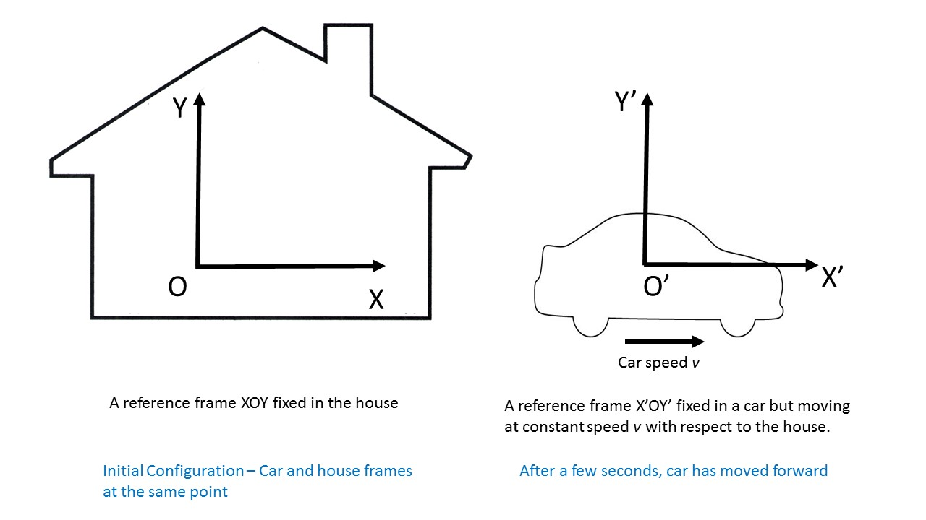

1. Let us assume that the frame of reference X’O’Y’ starts moving with constant speed relatively to the frame of reference XOY along the X axis. Write equations connecting the coordinates of the point B in the moving system and in the system at rest.

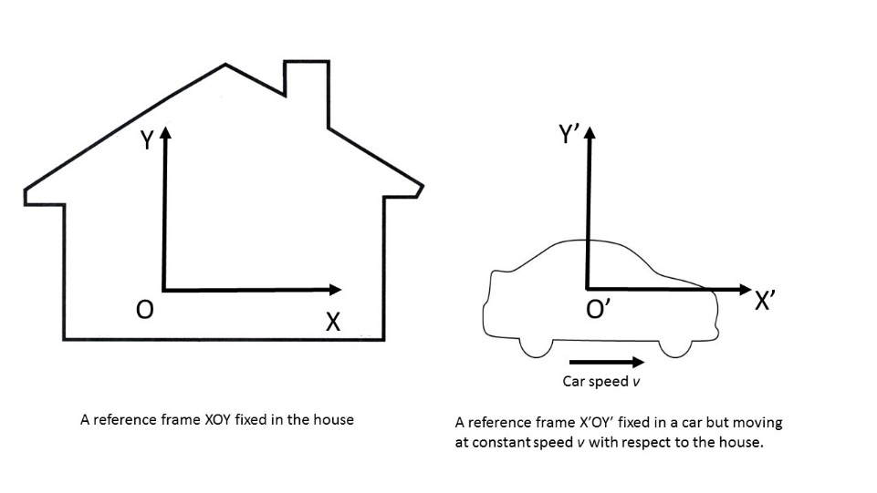

1. A boat travelling upstream at 5 km/h relative to the shore. If there is a current of 7 km/h which direction the boat is moving with respect to water? What is the boat’s speed relative to the water?

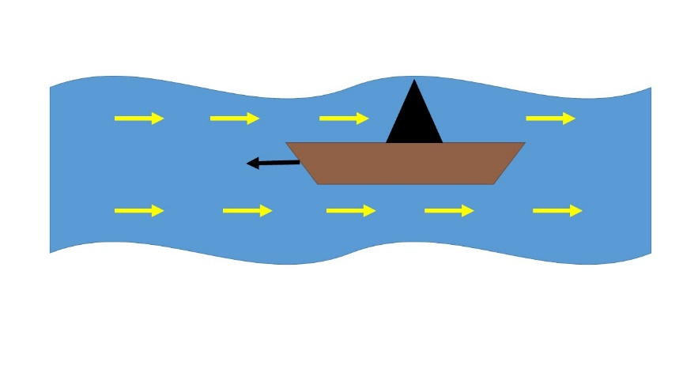

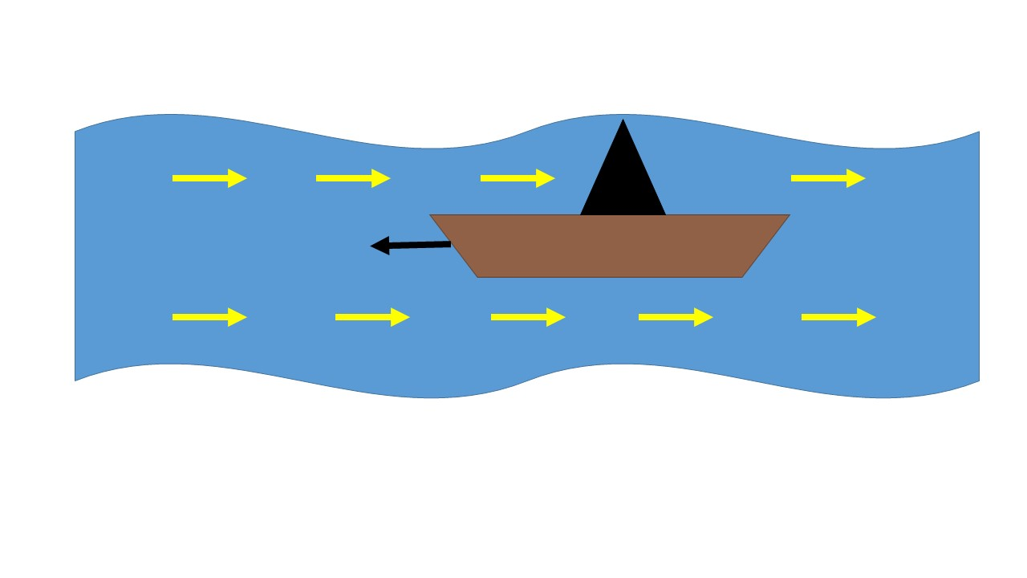

1. A jet plane travelling horizontally at 1200 km/h relative to the ground fires a rocket forwards at 1100 km/h relative to itself. What is the speed of the rocket relative to the ground?

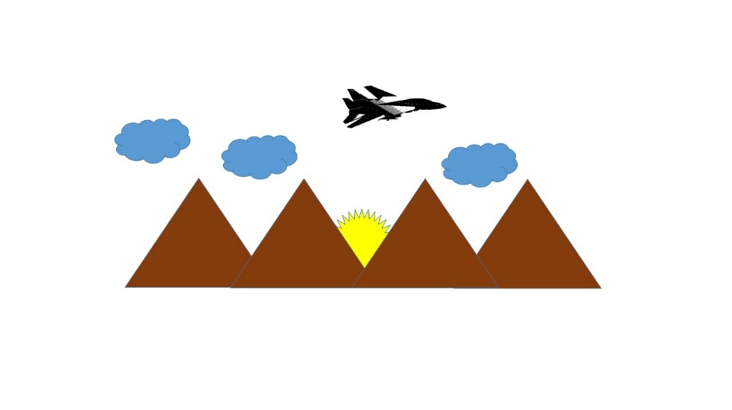

# **Lesson 2: Introduction to Spacetime Diagrams and the Light Cone**

## Teacher’s Guide

**Connections:**

|  |  |  |
| --- | --- | --- |
| Previous Lesson | Current Lesson | Next Lesson |
| Description of Motion, Galilean Relativity Principle | Introduction to Spacetime Diagrams | Regions on spacetime diagrams and the light cone |

|  |  |
| --- | --- |
| Objectives: | * To understand the notion of spacetime as one entity * To know the definitions of event and spacetime interval as a length in the geometry of space time * To construct world lines for different moving objects |
| Video(s): |  |
| Review: | Define light-year:  Measuring time in meters? Why not. This is the time light travels 1 meter of distance. It is better to have the same units on all the axes of the spacetime coordinate system. Alternatively, the distance could be measured in light-years (a unit of distance equivalent to the distance that light travels in one year, which is 6 trillion miles or nearly 10 trillion kilometers). For both cases *c* = 1. Hence distance = speed times time = *c t* = *t*. Therefore, we write *x* = *t*.  Define event: In physics, and in special relativity, an event is a point in spacetime (that is, a specific place and time).  Recall that the distance between two points in space can be written as:  Where *(x,y)* and *(X,Y)* are the coordinates of two points in space.  Now define ‘interval’ as separation between two events on a spacetime diagram:  Where we have defined coordinates of a point on a spacetime diagram as *(x, y, t)* and *(X, Y, T)*.  Considering same events in different frames we find that interval is invariant.  Construct the world line of a particle resting at the position of 2 meters from the reference event.  What is the shape of the world line if a material point moves along the *x* axis with a constant velocity? How can we know the speed of the point?  Construct the world line of light flash or a photon emitted from the reference event (the origin of the frame).  Can you construct the world line of a particle that moves with acceleration (which means it speed is changing with time)? |
| Discussion Questions: | A number of follow up questions can be asked to prepare for the next class   * What is the fundamental difference between interval (“distance”) in a spacetime diagram and distance in Newtonian space and time? * What is the shape of a world line of a particle moving with constant velocity?   Remind them that slope of a line is rise/run. Can the slope of a world line be less than 1? |
| Fun fact | Though Einstein is credited with the idea of putting space and time together, this is not historically correct!  In Encyclopedie, published in 1754, under the term dimension Jean le Rond d'Alembert speculated that duration (time) might be considered a fourth dimension if the idea was not too novel.  Another early venture was by Joseph Louis Lagrange in his Theory of Analytic Functions (1797, 1813). He said, "One may view mechanics as a geometry of four dimensions, and mechanical analysis as an extension of geometric analysis".  … So great minds had started thinking on these lines centuries before Einstein ! |

## Student’s Worksheet

**Lesson 2 Topic:** Introduction to Spacetime Diagrams and the Light Cone

**Objective:**

To learn spacetime diagrams and the light cone.

**Work:**

Convert time or distance to meters

5 nanoseconds = ________________ m

3 ms =­­_________________ m

1 light-second =_________________ m

1. In this diagram, which events (out of A, B, C and D) occur at the same time? Which events occur at the same place?



1. One division of the space axis corresponds to 1 meter. Construct a world line of the particle that is resting at 2 m from the reference event.



1. Time and distance are measured in meters construct the world line of the particle that is moving along the x-axis with the speed 0.2 m/m.



1. Construct the world line of a light ray (a photon) emitted at the origin and propagating along the x-axis.



1. Make a sketch of two particles that starting from different places move toward each other with constant velocities (not necessary the same magnitudes), and meet at some point of space.



# **Lesson 3: Regions on Spacetime Diagram**

## Teacher’s Guide

**Connections:**

|  |  |  |
| --- | --- | --- |
| Previous Lesson | Current Lesson | Next Lesson |
| Introduction to Spacetime Diagrams | Regions on spacetime diagrams and the light cone | Relativity of Simultaneity |

|  |  |
| --- | --- |
| Objectives: | * To distinguish between timelike, spacelike, and lightlike intervals * To understand the physical meaning of different interval types * To know the definition of a light cone in the spacetime geometry |
| Video(s): | Start with short video <https://www.youtube.com/watch?v=c0NuaATdzDE> that reminds the basic spacetime terminology. |
| Review: | The interval between two events is invariant (the value is the same) for all inertial frames of reference.  It is convenient to consider a frame that is at rest relative to the observer: the laboratory frame of reference is the usual choice.  Because (interval)2 = (time separation)2 – (distance)2  and (distance) = 0 in the lab system, the value of the interval equals to the time of the stationary observer, or her wristwatch time that is also called the **proper time.**  Ask students to calculate the intervals between the events given on the spacetime map. Calculate the total wristwatch time on the paths ABCD and AD. Make a comparison and conclude: In the spacetime geometry, a straight line corresponds to the longest interval.  What is the fundamental difference between **distance** in space and **interval** in spacetime? Distance squared is always positive. Interval squared can also be negative.  Depending on the sign of (interval)2 classify the interval between two events as timelike (positive), lighlike (zero), and spacelike (negative).  Emphasize that if the interval between two events is timelike a material object (particle) can travel between the events.  Space-like separated events could not be in a cause-and-effect connection, and no material particle can travel between such events because a material object cannot travel faster than the speed of light.  Ask the students to classify the intervals between the events 1, 2, and 3.  How many vectors of zero length do exist in (Euclidian) space? All events forming lightlike pairs with the reference event create a hypersurface in spacetime, which is called a light cone. A light cone creates partition of spacetime that classifies every event into the five different categories according to the casual relation.  Imagine a flash of light somewhere on xy plane. It will start to expand with time, as shown in the first three diagrams below. Viewed in another way by adding time axis in the vertical direction, it is easy to see that it will look like a cone! That’s where the concept of light-cone comes in.  Slide12  Slide11 |
| Discussion Questions | The students should suggest their ideas about the physical meaning of interval. |
| Discussion Questions – End | Discuss the question if spacelike intervals arise in nature. Example from the book: Signals from the supernova labeled 1987A reported that event for us in 1987. Which was 150,000 years after the explosion occurred. Yet occur it did! No astronomer of Babylonians, Egyptians, or Greek days reported it, nor could they even know of it. Yet it had already happened for them. That event separated itself from each of them by a spacelike interval. |
| Fun fact | History of cones: In mathematics, a conic section (or simply conic) is a curve obtained as the intersection of the surface of a cone with a plane. The three types of conic section are the hyperbola, the parabola, and the ellipse. The circle is a special case of the ellipse, and is of sufficient interest in its own right that it was sometimes called a fourth type of conic section. The conic sections have been studied by the ancient Greek mathematicians with this work culminating around 200 BC, when Apollonius of Perga undertook a systematic study of their properties.  https://upload.wikimedia.org/wikipedia/commons/thumb/1/11/Conic_Sections.svg/800px-Conic_Sections.svg.png  Ref: By http://commons.wikimedia.org/wiki/User:Magister_Mathematicae - http://commons.wikimedia.org/wiki/File:Secciones_c%C3%B3nicas.svg, CC BY-SA 3.0, https://commons.wikimedia.org/w/index.php?curid=18556148 |
| Reference: | Spacetime Physics by E. Taylor and J. Wheeler, second edition, W.H. Freeman and Company. |

## Student’s Worksheet

**Lesson 3 Topic:** Space and Spacetime Diagrams

**Objective:**

**Work:**

1. Interval in a spacetime map is defined as (interval)2 = (time separation)2 – (space separation)2. For any two events the interval is invariant for all inertial reference frames. If the space separation is zero what reference frame this interval corresponds to?
2. In the spacetime diagram, time and distance are measured in years. Calculate the time increase on the traveler’s clock while she travels from the point A to the point D through the points B and C. Calculate the wristwatch time if the traveler moves directly from the event A to event D. Compare the two times. What can you conclude?



1. Events 1, 2 and 3 all have laboratory locations *y* = *z* = 0. Their *x* and *t* measurements are shown on the laboratory spacetime map.



1. Classify the interval between the events 1 and 2 as timelike, spacelike, or lightlike.
2. Classify the interval between the events 1 and 3
3. Classify the interval between the events 2 and 3
4. Is it possible that one of the events caused the other event?
5. What is the proper time between two events?
6. For the timelike pair of the events, find the speed and direction of a rocket frame with respect to which the two events occurred at the same place (optional)
7. Three dimensional spacetime map showing eastward, northward, and time locations of events occurring on a flat plane in space is shown on the picture. The light cone shows the partition in spacetime.



1. Can a material particle emitted at A affect what is going to happen at B?
2. Can a light ray emitted at A affect what is going to happen at G?
3. Can no effect whatever produced at A affect what happens at D?
4. Can a material particle emitted at J affect what is happening at A?
5. Can a light ray emitted at H affect what is happening at A?

# **Lesson 4: Relativity of Simultaneity**

## Teacher’s Guide

**Connections:**

|  |  |  |
| --- | --- | --- |
| Previous Lesson | Current Lesson | Next Lesson |
| Regions on spacetime diagrams and the light cone | Relativity of Simultaneity | Resolving the Twin Paradox |

|  |  |
| --- | --- |
| Objectives: | * To understand the concepts of lines of same location and lines of same time (simultaneity lines) * To construct two frames of reference moving relative to each other on one spacetime plot * To demonstrate that simultaneity is relative: depends on the state of motion of the observer * To demonstrate time dilation: moving clock runs slow * To demonstrate length contraction: moving objects shrink along the direction of motion |
| Video(s): | Simultaneity, <https://www.youtube.com/watch?v=wteiuxyqtoM> |
| Main Activity | Once again, we’ll be using the units where *c* = 1 unless stated otherwise.  To explain that events occurring at some particular time form same time lines or lines of simultaneity, but events occurring at some particular location form same position lines on a spacetime diagram.  1. Asks students to construct world lines for different frames of reference. One of the frames is at rest. Let us say, it is related with Alice who is the observer on the Earth. The other one is moving with the constant velocity relative to the Alice’s one. Her friend Bob is riding a rocket that is passing by Alice. Bob is moving to the left relative to Alice. His world line in the Alice’s spacetime map is a straight line with the slope =  2. Relative to Bob, Alice is moving to the left with the same speed. Her world line in Bob’s frame has a negative slope.  3. Ask students to combine two frames in one plot. The key point here is the speed of light constancy for any inertial frame of reference. That means the world line of a flash of light is always a bisector between the positive directed time and space axes.  Let us start with Bob’s spacetime map on Alice’s spacetime map. Bob in his frame is at rest. During his motion relative to Alice he remains on the same position line that is his world line. Here is his time axis. The space axis can be easily constructed using the fact that the world line of light of the space and time axes.  4. Now, the Bob’s frame is stationary. Alice is moving in the opposite direction relative to Bob. Her world line, here time axis, has a negative slope. The direction of the light world line is the same for all frames. The Alice’s space axis is, therefore, below the Bob’s space axis.  5. The combined spacetime diagram where Alice is at rest, helps us to understand the main consequences of the postulates of Special Relativity, such as relativity of simultaneity, time dilation, and length contraction. The simultaneity lines and same position lines of Bob as seen by Alice are shown with dotted lines.  Events C and D are clearly simultaneous in Bob’s frame. In Alice’s prospective, the event C occurs earlier that the event D does. Simultaneity, therefore, is relative.  The events C and E are 2 time units apart in the Bob’s frame. In the Alice’s frame that is at rest, the time difference between the events C and E is clearly larger than 2 time units. The moving clocks are running slow.  The unit length in Bob’s frame looks shorter in the Alice frame: length contraction.  6. Events A and C can be reversed in time. In the stationary frame, the event A precedes event C. If some moving frame has the space axis going through point C than the event C occurs at zero instance. The event A occurs at a later time. |
| Fun fact |  |

## Student’s Worksheet

**Lesson 4 Topic:** Space and Spacetime Diagrams

**Objective:**

To construct spacetime diagrams for moving reference frames. To understand that simultaneity depends on a frame of reference. To understand time dilation and length contruction.

**Work:**

1. Alice is standing on the Earth. She is an observer. Bob is passing by Alice in a spaceship that has speed *v* = 0.6*c*. At time 0 meters (both time and distance are measured in meters) Alice and Bob are at the origin of the spacetime map, construct the world line of the Bob’s spaceship. At what time is he 5 m away from Alice?



1. Bob’s spaceship passing by Alice, who is on Earth, with speed *v* = 0.6*c*. He is now an observer. Construct the world line of Alice in the spacetime map of Bob.



1. The tilted line is the time axis of the Bob’s frame in the Alice’s frame of reference. In the system of units used the speed of light *c* = 1. What is the speed of Bob? The world line of a light flash is a bisector between the directions of time and space. Keeping this in mind, construct the space axis of the Bob’s frame. What are the slopes of the Bob’s axes in the Alice’s frame? Make a sketch of lines of simultaneity and same position lines in the Bob’s frame.



1. Construct the spacetime coordinate map of Alice in the Bob’s frame of reference. You remember, Alice is standing on Earth. Bob is flying to the right on his spaceship. Make a sketch of simultaneity lines and same position lines.



1. On the spacetime map, at what instants do events C and D occur in the Alice’s frame? In the Bob’s frame? Distance and time are measured in meters. Are these events simultaneous?

What is the interval between events C and E in the Bob’s frame? In the Alice’s frame? What clocks are running slow?

Take one unit of distance in the Bob’s frame, for example, the distance between marks 1 and 2. What can you say about the one-unit distance in the Alice’s frame?



# **Lesson 5: Resolving the Twin Paradox**

## Teacher’s Guide

**Connections:**

|  |  |  |
| --- | --- | --- |
| Previous Lesson | Current Lesson | Next Lesson |
| Relativity of Simultaneity | Resolving the Twin Paradox | More on Relativity |

|  |  |
| --- | --- |
| Objectives: | * To resolve the Twin Paradox |
| Video(s): | Briefly discuss why the Relativity Theory is paradoxical. Show a brief video, such as <https://www.youtube.com/watch?v=oOL2d-5-pJ8> or something else about paradoxes. |
| Main Activity | 1. Alice is travelling to the planet that is 3 light-years away from the Earth. Her space vehicle is moving at v = 0.6c, and reaches the destination after 5 years of travel in perspective of Bob, who remained on Earth. According to Alice, her outbound trip took years, her wristwatch time. The Alice clocks are running times slower than that of Bob. The inbound trip took the same 4 years. Upon returning to the Earth, Alice is 2 years younger than Bob. However, in perspective of Alice, Bob’s clocks are running 1.25 times slower than her clocks.  2. We can construct the two spacetime maps on one plot for the outbound trip and inbound trip separately. Indeed, it takes Alice 4 years four years to get to the destination. The Alice’s simultaneity lines indicated that only 3.2 years passed on the Bob’s clocks while Alice was on the outbound travel.  3. For the inbound trip, the Alice’s simultaneity lines have the different slope, indicating that according to the Bob’s clocks the Alice’s trip back lasted the same 3.2 years, between 6.8 years and 10 years of the entire travel time. What happened between the mark of 3.2 years and the mark of 6.8 years? Alice was decelerating and accelerating. The simultaneity lines were changing their slope, and Bob’s clocks were running faster.  4. Another, simpler resolution of the twin paradox could be given based on the properties of the spacetime geometry, where a straight line segment has the longest interval between two events (The Principle of Maximal Aging). The curve OB has smaller interval than the line OB that corresponds to Bob who stayed on Earth. |
| Fun fact |  |

## Student’s Worksheet

**Lesson 5 Topic:** Resolving the Twin Paradox

**Objective:**

To be able to resolve any paradox in the Special Theory of Relativity

**Work:**

1. Alice is traveling with speed v = 0.6c to the planet that is 3 light-years away from the Earth and back to the Earth. Bob is waiting on the Earth. The world line of Alice is shown on the Bob’s spacetime map. How much time one needs to Alice to reach the destination, according to her clocks? Bob’s clock? How much slow the Alice’s clocks are running relative to Bob’s ones? What is the total travel time on her clocks? On his clocks?



1. Spacetime maps for Alice and Bob are shown on one plot for the outbound trip. According to Alice, how long did she travel to the planet? On her wristwatch? What is the reading of the Bob’s clock in perspective of Alice at the instance when she reached the planet?



1. Spacetime maps for Alice and Bob are shown on one plot for the inbound trip. According to Alice, how long did she travel back home? On her wristwatch? What is the reading of the Bob’s clock in perspective of Alice at the instance when she reached the Earth? How long was Alice away from home in perspective of Bob? In perspective of Alice? Explain.



1. Resolution of the Twin Paradox could be given using the properties of the spacetime geometry. A straight line between two events always represents the longest interval. How can you demonstrate it?

